Week 2 Unit 6

working with odata services

Please perform the exercises below in your app project as shown in the video.

Table of Contents

1 Disable Batch Processing for Debugging 2

2 Display Data From a Related Entity Using Expand 3

3 (Optional) Update Mock Server Metadata 5

## Preview

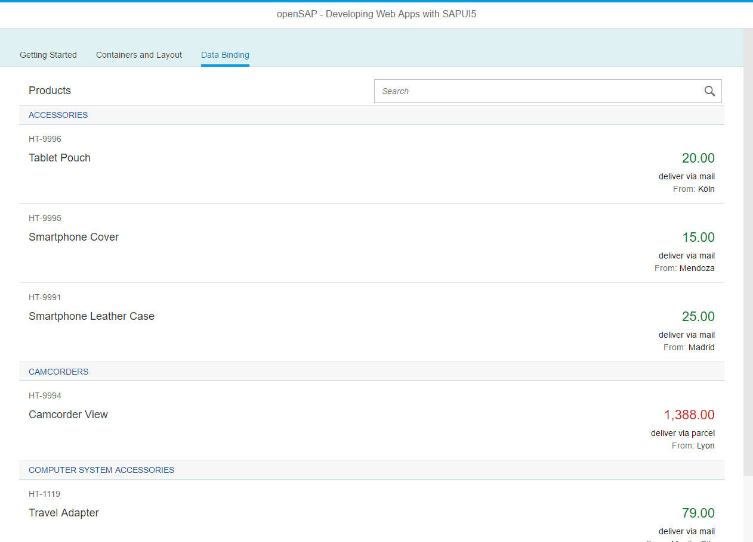

Figure 1 - Preview of the app after doing this unit’s exercises

# 

# Disable Batch Processing for Debugging

In this step, we manually turn off batch processing to inspect the calls of the OData model.

### webapp/Component.js

sap.ui.define([

"sap/ui/core/UIComponent"

], function (UIComponent) {

"use strict";

return UIComponent.extend("opensap.myapp.Component", {

metadata : {

manifest: "json"

},

init : function () {

// call the init function of the parent

UIComponent.prototype.init.apply(this, arguments);

**// used only for this lessons to show the request individually...**

**this.getModel().setUseBatch(false);**

// additional initialization can be done here

}

});

});

In the init method of the component, we add a single line that manually turns off batch processing to be able to debug calls from the ODataModel to the server easily. By default, batch processing is turned on in SAPUI5, so all calls that would otherwise be sent to a server in a single request are composed to a batch request that combines multiple requests.

This is a great performance boost, especially when network latency is high, but also makes debugging hard. That is why we manually turn off batch processing in our app so that you can analyze how changes in your app - for example adding or removing filters - influence the calls sent to the backend service.

**Note: Only do this for testing!**  
Do not turn of batch processing in productive applications as it might slow down the application flow and impact performance negatively!

# Display Data From a Related Entity Using Expand

In this step, we will expand the list binding to show data from another OData entity

### webapp/view/App.view.xml

<mvc:View>

…

<List

id="productsList"

items="{

path: '/ProductSet',

**parameters : {**

**expand: 'ToSupplier'**

**},**

sorter : {

path : 'Category',

group : true

}

}"

growing="true"

growingThreshold="5"

growingScrollToLoad="false">

<headerToolbar>

<Toolbar>

<Title text="{i18n>productListTitle}"/>

<ToolbarSpacer/>

<SearchField width="50%" search="onFilterProducts"/>

</Toolbar>

</headerToolbar>

<items>

<ObjectListItem

title="{Name}"

number="{Price}"

numberState="{= ${Price} > 500 ? 'Error' : 'Success'}"

intro="{ProductID}"

press="onItemSelected"

type="Active">

<firstStatus>

<ObjectStatus text="{

parts: [

{path: 'WeightUnit'},

{path: 'WeightMeasure'}

],

formatter : '.formatter.delivery'

}"/>

</firstStatus>

**<secondStatus>**

**<ObjectStatus**

**title="{i18n>statusDeliveryFrom}"**

**text="{ToSupplier/Address/City}"/>**

**</secondStatus>**

</ObjectListItem>

</items>

</List>

…

</mvc:View>

In this step we want to use the OData query parameter $expand to be able to display additional information from a related entity.

First we have to add the parameter to the list binding. For that, we use the parameters setting in the binding and pass the ToSupplier navigation property to this parameter. We can now use properties from this entity using relative paths. We add the secondStatus aggregation to our list item and add an sap.m.ObjectStatus control into it. We bind its property text to the City property in the BusinessPartner entity of the service, which is the target type of navigation property ToSupplier.

### webapp/i18n/i18n.properties

…

# Data Binding Content

productListTitle=Products

...

**statusDeliveryFrom=From**

…

As we use a new translatable text, we adjust the i18n file as well.

**Note: Mock Server and expands**  
If you use the mock data workaround, your page might stay blank at this point and there is an error in the console saying that the ‘ToSupplier’ path could not be resolved. The service metadata does not contain this navigation property yet, so replace your metadata with the contents in the next step.

### Related Information

[OData.org](http://odata.org)

# (Optional) Update Mock Server Metadata

If using the mock server, we need to modify the service metadata so that the supplier expand can be mocked. The value will remain empty however, as the mock server is not able to automatically generate mock data for expanded entities.

**Note:**This workaround is only applicable if you are using the mock server as described in week 2 unit 1. It will create random test data in your app if the service connection is too slow during these exercises. The MockServer will be explained later in the course in more detail and would be set up a bit differently in a real project.

### webapp/metadata.xml

**<?xml version="1.0" encoding="utf-8"?>**

**<edmx:Edmx Version="1.0"**

**xmlns:edmx="http://schemas.microsoft.com/ado/2007/06/edmx"**

**xmlns:m="http://schemas.microsoft.com/ado/2007/08/dataservices/metadata"**

**xmlns:sap="http://www.sap.com/Protocols/SAPData">**

**<edmx:DataServices m:DataServiceVersion="2.0">**

**<Schema**

**xmlns="http://schemas.microsoft.com/ado/2008/09/edm"**

**Namespace="/IWBEP/GWSAMPLE_BASIC"**

**xml:lang="en"**

**sap:schema-version="1">**

**<EntityType Name="BusinessPartner" sap:content-version="1">**

**<Key>**

**<PropertyRef Name="BusinessPartnerID"/>**

**</Key>**

**<Property Name="Address" Type="/IWBEP/GWSAMPLE_BASIC.CT_Address" Nullable="false"/>**

**<Property Name="BusinessPartnerID" Type="Edm.String" Nullable="false" MaxLength="10" sap:label="Geschäftspartner-ID" sap:creatable="false" sap:updatable="false"/>**

**<Property Name="CompanyName" Type="Edm.String" Nullable="false" MaxLength="80" sap:label="Firma"/>**

**<Property Name="WebAddress" Type="Edm.String" sap:sortable="false" sap:filterable="false" sap:semantics="url"/>**

**<Property Name="EmailAddress" Type="Edm.String" Nullable="false" MaxLength="255" sap:label="E-Mail" sap:semantics="email"/>**

**<Property Name="PhoneNumber" Type="Edm.String" MaxLength="30" sap:label="Telefonnr." sap:semantics="tel"/>**

**<Property Name="FaxNumber" Type="Edm.String" MaxLength="30"/>**

**<Property Name="LegalForm" Type="Edm.String" MaxLength="10" sap:label="Rechtsform"/>**

**<Property Name="CurrencyCode" Type="Edm.String" Nullable="false" MaxLength="5" sap:label="Währungscode" sap:semantics="currency-code"/>**

**<Property Name="BusinessPartnerRole" Type="Edm.String" Nullable="false" MaxLength="3" sap:label="GeschPartnRolle"/>**

**<Property Name="CreatedAt" Type="Edm.DateTime" Precision="7" sap:label="Zeitstempel" sap:creatable="false" sap:updatable="false"/>**

**<Property Name="ChangedAt" Type="Edm.DateTime" Precision="7" ConcurrencyMode="Fixed" sap:label="Zeitstempel" sap:creatable="false" sap:updatable="false"/>**

**</EntityType>**

**<EntityType Name="Product">**

**<Key>**

**<PropertyRef Name="ProductID"/>**

**</Key>**

**<Property Name="ProductID" Type="Edm.String" Nullable="false" MaxLength="10"/>**

**<Property Name="TypeCode" Type="Edm.String" Nullable="false" MaxLength="2"/>**

**<Property Name="Category" Type="Edm.String" Nullable="false" MaxLength="40"/>**

**<Property Name="Name" Type="Edm.String" Nullable="false" MaxLength="255"/>**

**<Property Name="NameLanguage" Type="Edm.String" MaxLength="2"/>**

**<Property Name="Description" Type="Edm.String" MaxLength="255"/>**

**<Property Name="DescriptionLanguage" Type="Edm.String" MaxLength="2"/>**

**<Property Name="SupplierID" Type="Edm.String" Nullable="false" MaxLength="10"/>**

**<Property Name="SupplierName" Type="Edm.String" MaxLength="80"/>**

**<Property Name="TaxTarifCode" Type="Edm.Byte" Nullable="false"/>**

**<Property Name="MeasureUnit" Type="Edm.String" Nullable="false" MaxLength="3"/>**

**<Property Name="WeightMeasure" Type="Edm.Decimal" Precision="13" Scale="3"/>**

**<Property Name="WeightUnit" Type="Edm.String" MaxLength="3"/>**

**<Property Name="CurrencyCode" Type="Edm.String" Nullable="false" MaxLength="5"/>**

**<Property Name="Price" Type="Edm.Decimal" Precision="16" Scale="3"/>**

**<Property Name="Width" Type="Edm.Decimal" Precision="13" Scale="3"/>**

**<Property Name="Depth" Type="Edm.Decimal" Precision="13" Scale="3"/>**

**<Property Name="Height" Type="Edm.Decimal" Precision="13" Scale="3"/>**

**<Property Name="DimUnit" Type="Edm.String" MaxLength="3" sap:label="Dimension Unit"/>**

**<Property Name="CreatedAt" Type="Edm.DateTime" Precision="7"/>**

**<Property Name="ChangedAt" Type="Edm.DateTime" Precision="7" ConcurrencyMode="Fixed"/>**

**<NavigationProperty Name="ToSupplier" Relationship="/IWBEP/GWSAMPLE_BASIC.Assoc_Products_BusinessPartner" FromRole="FromRole_Assoc_Products_BusinessPartner" ToRole="ToRole_Assoc_Products_BusinessPartner"/>**

**</EntityType>**

**<EntityContainer Name="/IWBEP/GWSAMPLE_BASIC_Entities" m:IsDefaultEntityContainer="true">**

**<EntitySet Name="BusinessPartnerSet" EntityType="/IWBEP/GWSAMPLE_BASIC.BusinessPartner" sap:content-version="1"/>**

**<EntitySet Name="ProductSet" EntityType="/IWBEP/GWSAMPLE_BASIC.Product"/>**

**<Association Name="Assoc_Products_BusinessPartner" sap:content-version="1">**

**<End Type="/IWBEP/GWSAMPLE_BASIC.BusinessPartner" Multiplicity="1" Role="FromRole_Assoc_BusinessPartner_Products"/>**

**<End Type="/IWBEP/GWSAMPLE_BASIC.Product" Multiplicity="*" Role="ToRole_Assoc_BusinessPartner_Products"/>**

**<ReferentialConstraint>**

**<Principal Role="FromRole_Assoc_Products_BusinessPartner">**

**<PropertyRef Name="SupplierID"/>**

**</Principal>**

**<Dependent Role="ToRole_Assoc_Products_BusinessPartner">**

**<PropertyRef Name="BusinessPartnerID"/>**

**</Dependent>**

**</ReferentialConstraint>**

**</Association>**

**<AssociationSet Name="Assoc_Products_BusinessPartner_AssocSet" Association="/IWBEP/GWSAMPLE_BASIC.Assoc_Products_BusinessPartner" sap:creatable="false" sap:updatable="false" sap:deletable="false" sap:content-version="1">**

**<End EntitySet="ProductSet" Role="FromRole_Assoc_Products_BusinessPartner"/>**

**<End EntitySet="BusinessPartnerSet" Role="ToRole_Assoc_Products_BusinessPartner"/>**

**</AssociationSet>**

**</EntityContainer>**

**</Schema>**

**</edmx:DataServices>**

**</edmx:Edmx>**

Replace the contents of the file metadata.xml with the updated service interface. The entity BusinessPartner has been added.

**Coding Samples**

Any software coding or code lines/strings (“Code”) provided in this documentation are only examples and are not intended for use in a productive system environment. The Code is only intended to better explain and visualize the syntax and phrasing rules for certain SAP coding. SAP does not warrant the correctness or completeness of the Code provided herein and SAP shall not be liable for errors or damages cause by use of the Code, except where such damages were caused by SAP with intent or with gross negligence.